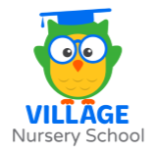
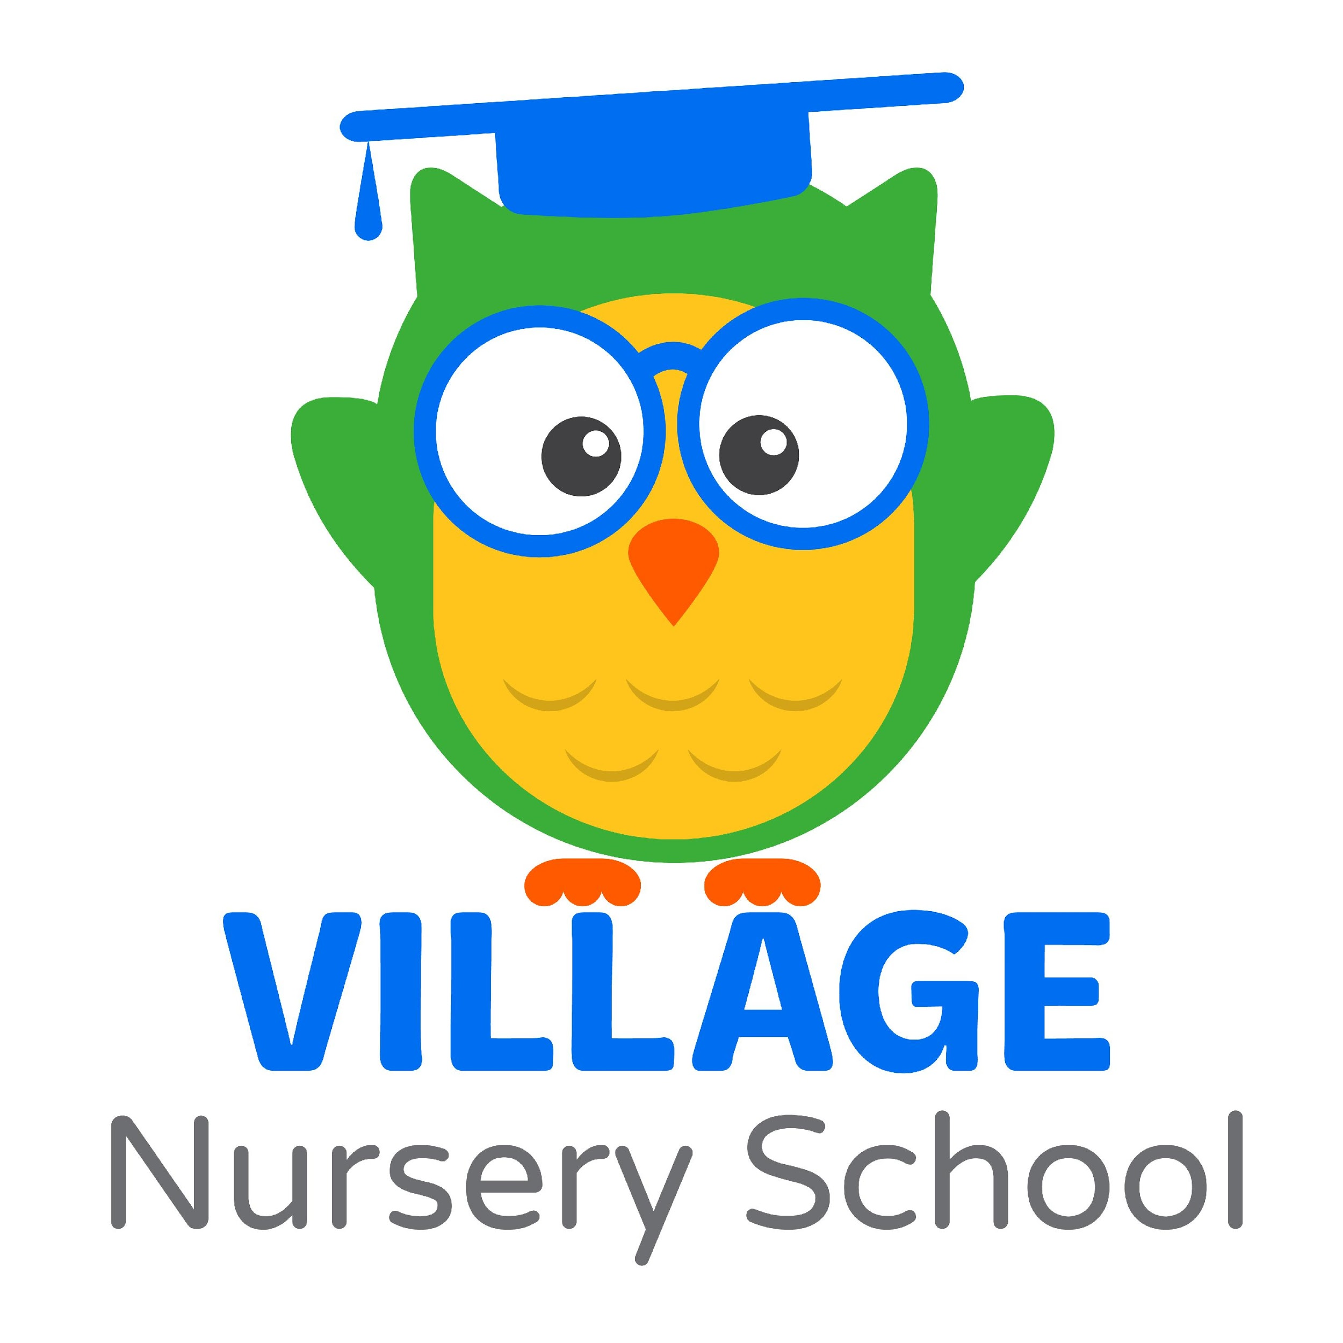
Village Nursery School Parent Infant Toddler (PIT)
Tuesday, Wednesday, or Thursday from 9:30-11 am
Julia Deery, Director
(765)743-4039 www.vnswl.com

We all need a Village when it comes to parenting, and PIT is a great place to introduce you to our Village! PIT is a class your child attends with you, a grandparent, or another caregiver, so it is a great introduction to a preschool setting where your child can explore with a trusted adult present. Each week the teacher presents a different theme and includes crafts and activities related to the theme during Activity Time. You child is exposed to a variety of toys and materials for caregivers and child to explore together. Examples may be building and transportation toys, shape and color sorters, puzzles, play dough, paint, and a sensory table for sand and water play. There is plenty of time for socializing for caregivers and children during this time as well. Parents provide their own snack, and then everyone participates (as they are able) in a short circle time. During circle time, the teacher shares songs and fingerplays then reads a story. Class ends with large motor play in a separate classroom. P-I-T classes meet for two 12 week sessions. The first beginning in September and the second beginning in January. The age-appropriate (12-24+ months)

Daily Schedule  - 9:30-10:10~ Activity time: crafts, toys, sensory bin  - 10:10-10:20~ Snack time (self provided)  - 10:20-10:30~ Circle Time  - 10:30-11 am~ Large Motor Time | PIT Offers:  -A caring and creative teacher who helps build community and provides an enriching experience.  -Crafts with opportunities to work on fine motor skills and sensory play  -Practice sharing and taking turns  -A language-rich environment to promote social skills and communication



